**Small Business Network Design 1 switch**

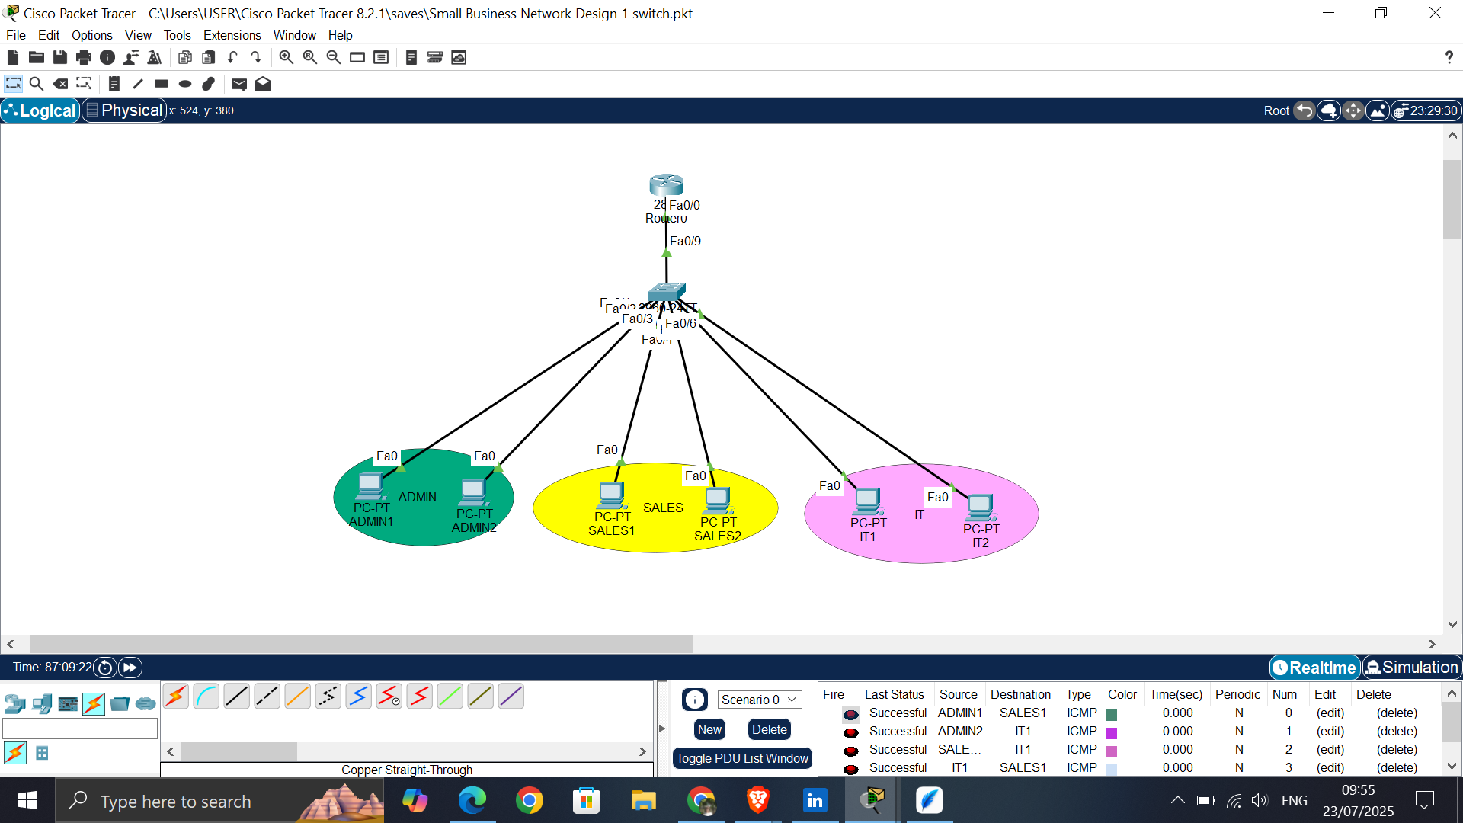

3 departments: Admin, Sales, and IT

Task: You are to set up VLANs for each department and configure inter-VLAN routing to enable communication between them.

1. Add Network Devices and Identification with color codes

* Cisco 2811 Router (1)
* Cisco 2960 switch (1)
* End Device - PC (6)

1. Connect Network Devices with copper straight-through cable.
2. Assign IP Addresses and Default gateways
3. Determine IP Address Class and Subnetting

* A class C IP Address (Usually preferred for medium to small sized networks) and it ranges from 192.0.0.0 to 223.255.255.255.
* **VLAN 10 (Admin)**: 192.168.10.0/24
* **VLAN 20 (Sales)**: 192.168.20.0/24
* **VLAN 30 (IT)**: 192.168.30.0/24

1. Configure VLANs on switch

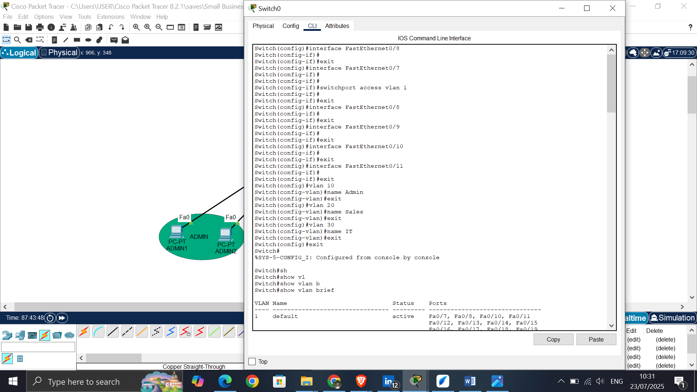

1. Assign Ports for each VLAN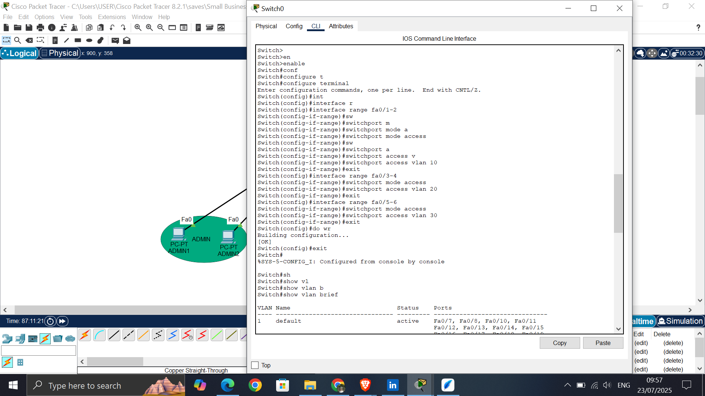
2. Configure Trunk Port on Switch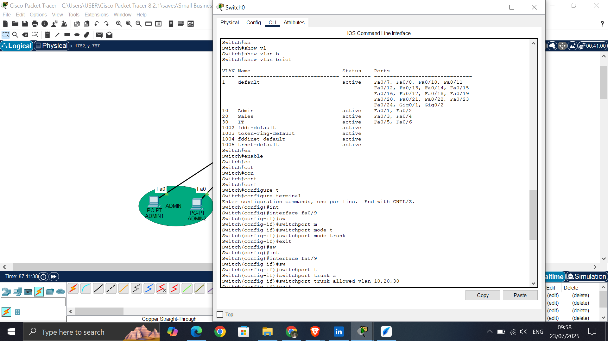
3. Configure Inter-VLAN Routing on the Router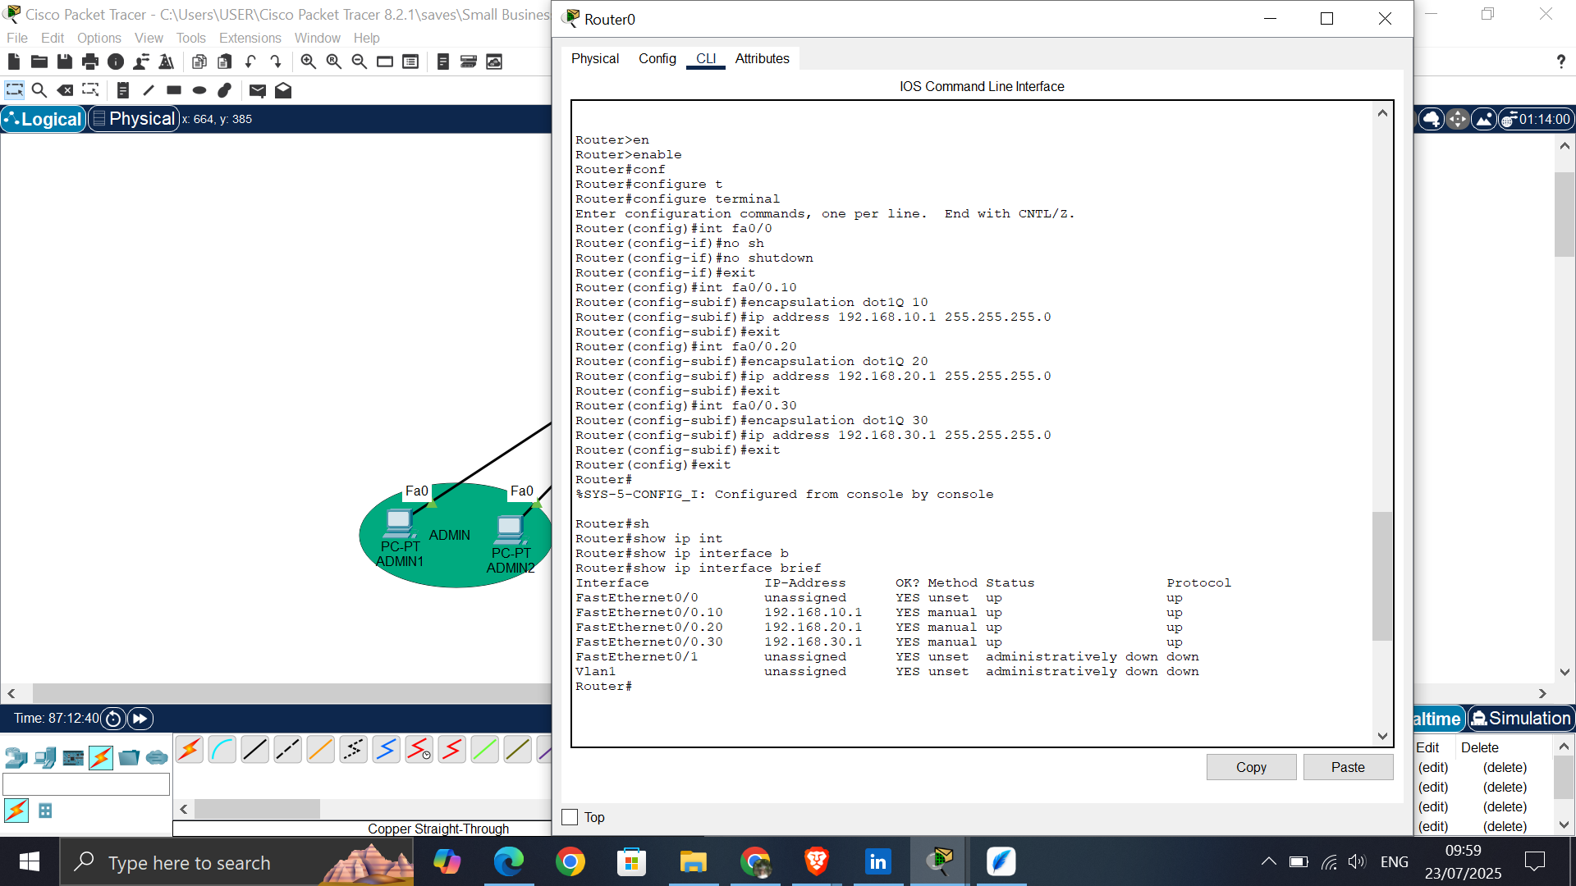
4. Verify Connectivity by pinging and entering simulation mode.

